Michaelle Jean

Assigned to: Natasha

Reporting Month: March 2025

# Results and Discussion

# Appendix A: SGS Tables & Graphs

## Mixed Sewage Table

|  |  |  |  |  |
| --- | --- | --- | --- | --- |
| Date | BOD5 | TSS | TKN | TAN |
| 09-Jan-25 | 71 | 31 | 52.7 | 35.9 |
| 06-Feb-25 | 166 | 117 | 76 | 70.4 |
| 17-Mar-25 | 98 | 64 | 31.3 | 19.6 |

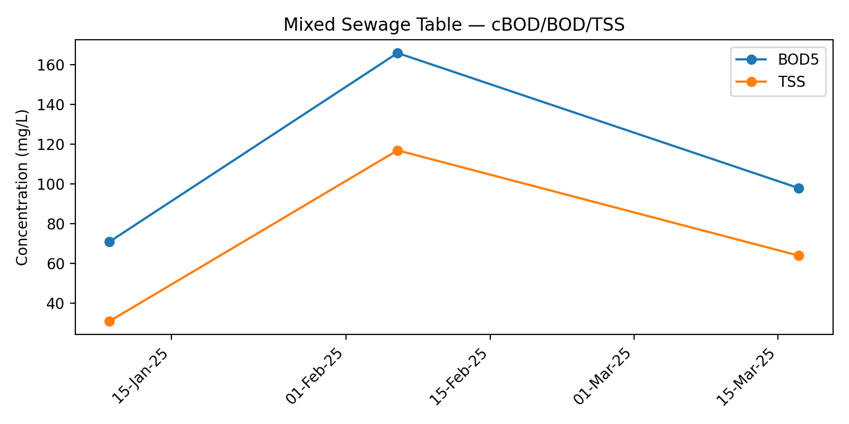

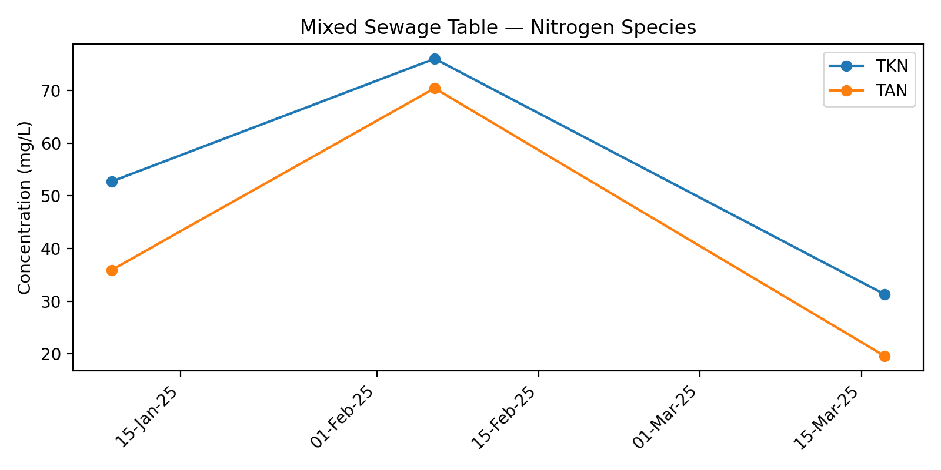

## Biofilter Effluent Table

|  |  |  |  |  |  |  |
| --- | --- | --- | --- | --- | --- | --- |
| Date | cBOD5 | TSS | TKN | TAN | NO2 | NO3 |
| 09-Jan-25 | 3 | 3 | 10.5 | 10.7 | 0.3 | 17.3 |
| 06-Feb-25 | 5 | 4 | 28.8 | 26.7 | 0.03 | 28.5 |
| 17-Mar-25 | 6 | 8 | 15.5 | 15.2 | 0.06 | 25.1 |

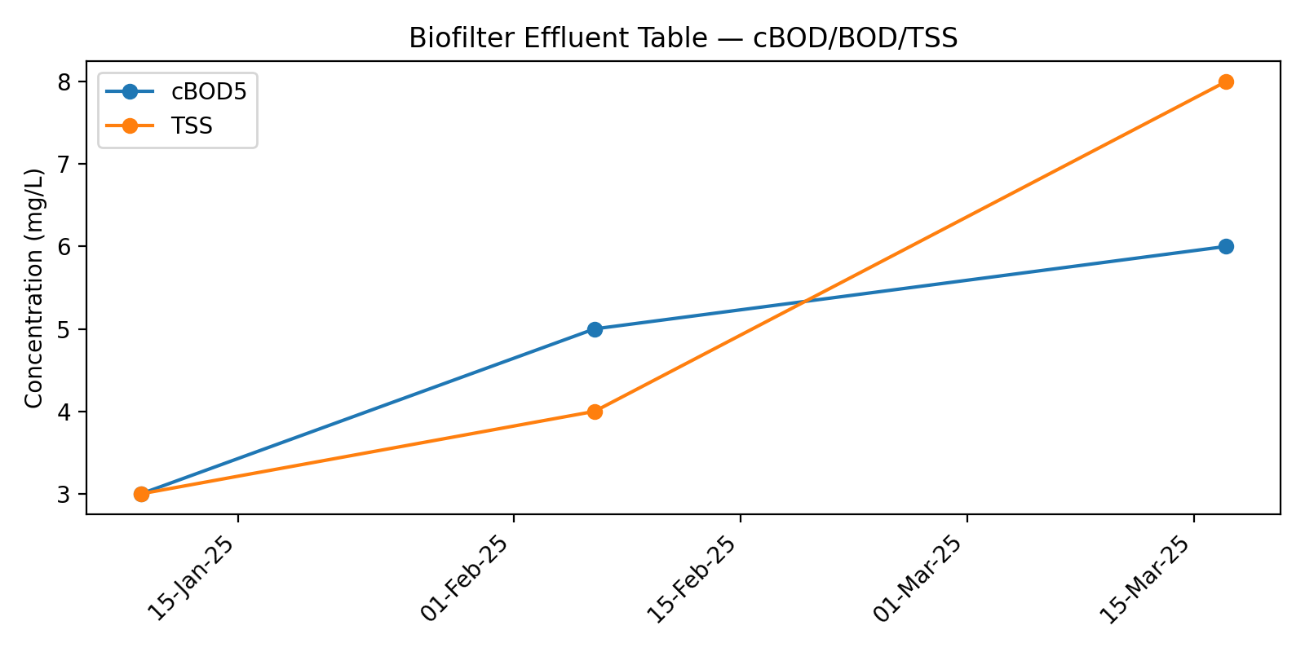

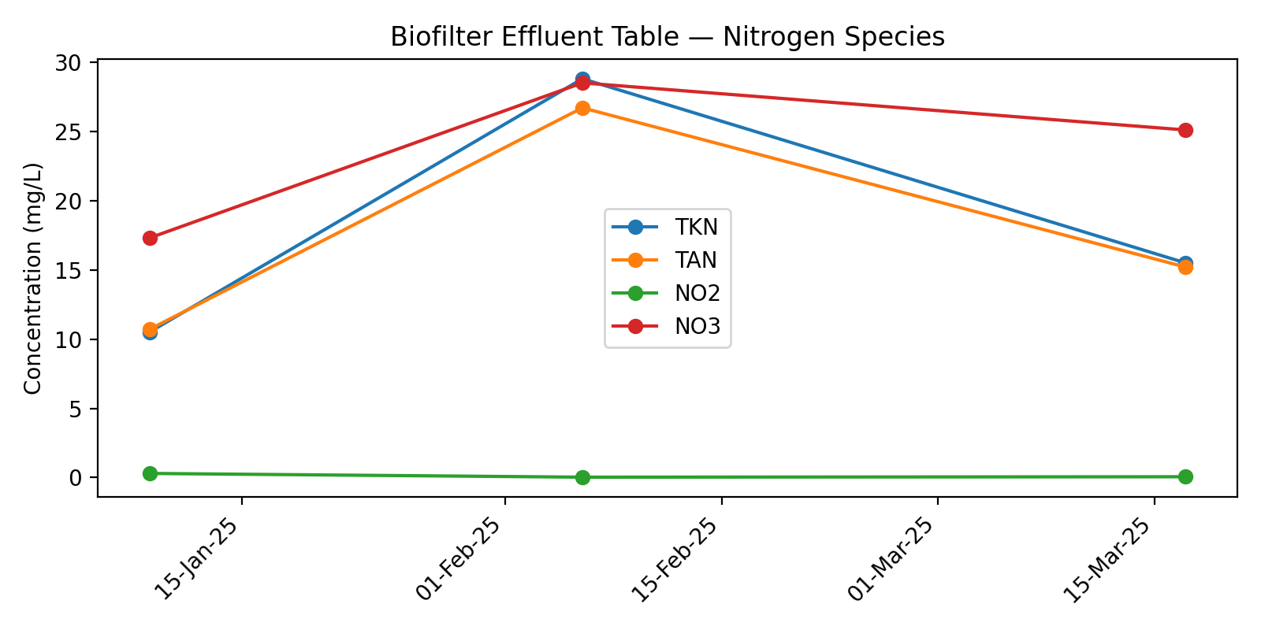

# Appendix B: Flow Data — January 2025

## Jan 25

|  |  |  |  |
| --- | --- | --- | --- |
| Date | Disposal 1 (L/day) | Disposal 2 (L/day) | Total Daily Flow (L/day) |
| 01-Jan-25 | 4887 | 0 | 4887 |
| 02-Jan-25 | 0 | 4986 | 4986 |
| 03-Jan-25 | 10471 | 6163 | 16634 |
| 04-Jan-25 | 0 | 4536 | 4536 |
| 05-Jan-25 | 4570 | 0 | 4570 |
| 06-Jan-25 | 5880 | 4665 | 10545 |
| 07-Jan-25 | 11720 | 17920 | 29640 |
| 08-Jan-25 | 17639 | 10971 | 28610 |
| 09-Jan-25 | 11421 | 16662 | 28083 |
| 10-Jan-25 | 14627 | 16249 | 30876 |
| 11-Jan-25 | 4949 | 0 | 4949 |
| 12-Jan-25 | 0 | 4631 | 4631 |
| 13-Jan-25 | 5109 | 6299 | 11408 |
| 14-Jan-25 | 4921 | 6158 | 11079 |
| 15-Jan-25 | 5008 | 6210 | 11218 |
| 16-Jan-25 | 4945 | 5972 | 10917 |
| 17-Jan-25 | 4668 | 6188 | 10856 |
| 18-Jan-25 | 5208 | 0 | 5208 |
| 19-Jan-25 | 0 | 4770 | 4770 |
| 20-Jan-25 | 4751 | 5661 | 10412 |
| 21-Jan-25 | 4798 | 5923 | 10721 |
| 22-Jan-25 | 4508 | 5674 | 10182 |
| 23-Jan-25 | 5050 | 6237 | 11287 |
| 24-Jan-25 | 4662 | 0 | 4662 |
| 25-Jan-25 | 0 | 5202 | 5202 |
| 26-Jan-25 | 4777 | 0 | 4777 |
| 27-Jan-25 | 5830 | 4548 | 10378 |
| 28-Jan-25 | 5859 | 4690 | 10549 |
| 29-Jan-25 | 5867 | 4449 | 10316 |
| 30-Jan-25 | 5260 | 5729 | 10989 |
| 31-Jan-25 | 6041 | 4467 | 10508 |
| Total Flow (L) |  |  | 348386 |
| Average Flow (L/day) |  |  | 11238 |

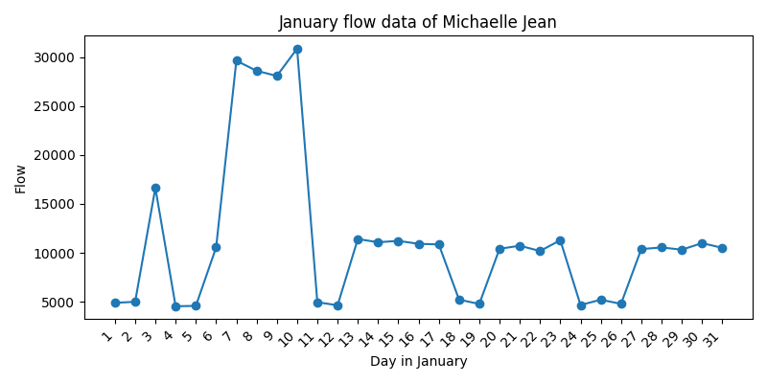

# Appendix C: Site Notes

# Appendix B: Flow Data — February 2025

## Feb 25

|  |  |  |  |
| --- | --- | --- | --- |
| Date | Disposal 1 (L/day) | Disposal 2 (L/day) | Total Daily Flow (L/day) |
| 01-Feb-25 | 0 | 4425 | 4425 |
| 02-Feb-25 | 4637 | 0 | 4637 |
| 03-Feb-25 | 5914 | 4616 | 10530 |
| 04-Feb-25 | 6339 | 4579 | 10918 |
| 05-Feb-25 | 5818 | 5386 | 11204 |
| 06-Feb-25 | 93 | 4792 | 4885 |
| 07-Feb-25 | 4514 | 5978 | 10492 |
| 08-Feb-25 | 5023 | 0 | 5023 |
| 09-Feb-25 | 0 | 4724 | 4724 |
| 10-Feb-25 | 4751 | 6018 | 10769 |
| 11-Feb-25 | 5741 | 4465 | 10206 |
| 12-Feb-25 | 4489 | 5738 | 10227 |
| 13-Feb-25 | 4718 | 0 | 4718 |
| 14-Feb-25 | 6114 | 4681 | 10795 |
| 15-Feb-25 | 0 | 5340 | 5340 |
| 16-Feb-25 | 5060 | 0 | 5060 |
| 17-Feb-25 | 0 | 4844 | 4844 |
| 18-Feb-25 | 4893 | 5914 | 10807 |
| 19-Feb-25 | 6010 | 5812 | 11822 |
| 20-Feb-25 | 5232 | 6012 | 11244 |
| 21-Feb-25 | 5572 | 5973 | 11545 |
| 22-Feb-25 | 5250 | 0 | 5250 |
| 23-Feb-25 | 0 | 4785 | 4785 |
| 24-Feb-25 | 4838 | 5855 | 10693 |
| 25-Feb-25 | 5643 | 5899 | 11542 |
| 26-Feb-25 | 17587 | 10434 | 28021 |
| 27-Feb-25 | 16619 | 18034 | 34653 |
| 28-Feb-25 | 0 | 5902 | 5902 |
| Total Flow (L) |  |  | 275061 |
| Average Flow (L/day) |  |  | 9824 |

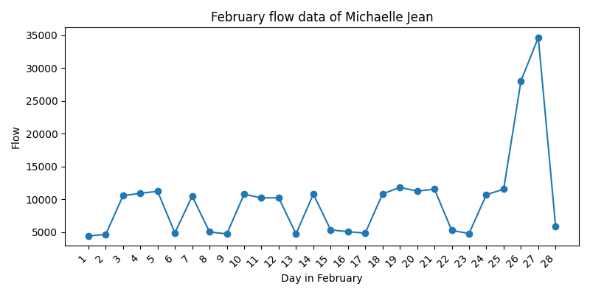

# Appendix C: Site Notes

# Appendix B: Flow Data — March 2025

## Mar 25

|  |  |  |  |
| --- | --- | --- | --- |
| Date | Disposal 1 (L/day) | Disposal 2 (L/day) | Total Daily Flow (L/day) |
| 01-Mar-25 | 5714 | 0 | 5714 |
| 02-Mar-25 | 0 | 4822 | 4822 |
| 03-Mar-25 | 4560 | 5815 | 10375 |
| 04-Mar-25 | 5565 | 5809 | 11374 |
| 05-Mar-25 | 11378 | 5896 | 17274 |
| 06-Mar-25 | 5211 | 9542 | 14753 |
| 07-Mar-25 | 4887 | 5890 | 10777 |
| 08-Mar-25 | 4662 | 0 | 4662 |
| 09-Mar-25 | 0 | 4797 | 4797 |
| 10-Mar-25 | 4822 | 0 | 4822 |
| 11-Mar-25 | 0 | 5680 | 5680 |
| 12-Mar-25 | 5365 | 0 | 5365 |
| 13-Mar-25 | 0 | 5497 | 5497 |
| 14-Mar-25 | 5368 | 0 | 5368 |
| 15-Mar-25 | 0 | 5344 | 5344 |
| 16-Mar-25 | 4810 | 0 | 4810 |
| 17-Mar-25 | 5455 | 5556 | 11011 |
| 18-Mar-25 | 5938 | 5649 | 11587 |
| 19-Mar-25 | 5985 | 10082 | 16067 |
| 20-Mar-25 | 5812 | 5550 | 11362 |
| 21-Mar-25 | 5146 | 4622 | 9768 |
| 22-Mar-25 | 4677 | 0 | 4677 |
| 23-Mar-25 | 0 | 4567 | 4567 |
| 24-Mar-25 | 4884 | 5808 | 10692 |
| 25-Mar-25 | 5828 | 4937 | 10765 |
| 26-Mar-25 | 10869 | 4631 | 15500 |
| 27-Mar-25 | 5066 | 5596 | 10662 |
| 28-Mar-25 | 5938 | 4706 | 10644 |
| 29-Mar-25 | 0 | 5176 | 5176 |
| 30-Mar-25 | 4961 | 0 | 4961 |
| 31-Mar-25 | 5889 | 5338 | 11227 |
| Total Flow (L) |  |  | 270100 |
| Average Flow (L/day) |  |  | 8713 |

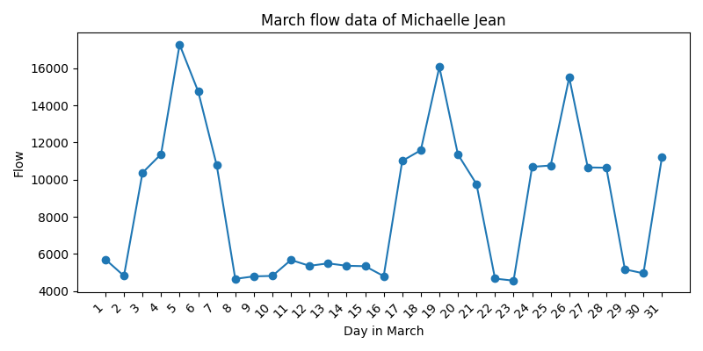

# Appendix C: Site Notes